Database Soal Sistem Informasi AIK21353

**DAFTAR ISI**

DAFTAR ISI ....................................................................................................... 1 UJIAN TENGAH SEMESTER 2007/2008............................................... 3 UJIAN TENGAH SEMESTER 2008/2009............................................... 4 UJIAN TENGAH SEMESTER 2010/2011............................................... 5 UJIAN AKHIR SEMESTER ............................................................................ 6 UJIAN AKHIR SEMESTER 2007/2008 ................................................... 7 UJIAN AKHIR SEMESTER 2008/2009 ................................................... 8 UJIAN TENGAH SEMESTER 2010/2011............................................... 9 UJIAN AKHIR SEMESTER 2010/2011 ................................................. 10

UJIAN TENGAH SEMESTER 2013/2014............................................. 11 UJIAN TENGAH SEMESTER 2014/2015............................................. 12 UJIAN TENGAH SEMESTER 2015/2016............................................. 13 UJIAN TENGAH SEMESTER 2018/2019............................................ 14

UJIAN AKHIR SEMESTER 2019/2020................................................. 15

DIKLAT HMIF Page 2

Database Soal Sistem Informasi

**UJIAN TENGAH SEMESTER 2007/2008**

****AIK21353

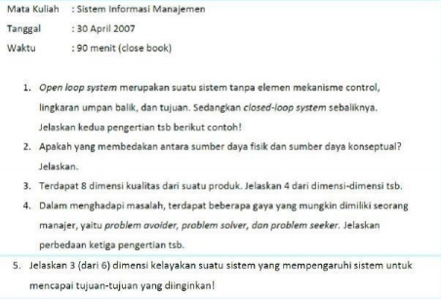DIKLAT HMIF Page 3

Database Soal Sistem Informasi AIK21353 **UJIAN TENGAH SEMESTER 2008/2009** 

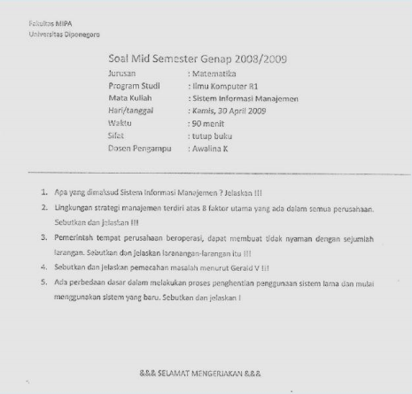DIKLAT HMIF Page 4

Database Soal Sistem Informasi AIK21353 **UJIAN TENGAH SEMESTER 2010/2011** 

****DIKLAT HMIF Page 5

Database Soal Sistem Informasi AIK21353 **UJIAN AKHIR SEMESTER** 

****DIKLAT HMIF Page 6

Database Soal Sistem Informasi

**UJIAN AKHIR SEMESTER 2007/2008**

****AIK21353

DIKLAT HMIF Page 7

Database Soal Sistem Informasi AIK21353 **UJIAN AKHIR SEMESTER 2008/2009**

****DIKLAT HMIF Page 8

Database Soal Sistem Informasi AIK21353 **UJIAN TENGAH SEMESTER 2010/2011**

****DIKLAT HMIF Page 9

Database Soal Sistem Informasi AIK21353 **UJIAN AKHIR SEMESTER 2010/2011**

****DIKLAT HMIF Page 10

Database Soal Sistem Informasi

**UJIAN TENGAH SEMESTER 2013/2014**

****AIK21353

DIKLAT HMIF Page 11

Database Soal Sistem Informasi 

**UJIAN TENGAH SEMESTER 2014/2015**

****AIK21353

DIKLAT HMIF Page 12

Database Soal Sistem Informasi AIK21353 UJIAN TENGAH SEMESTER 2015/2016 

DIKLAT HMIF Page 13

Database Soal Sistem Informasi AIK21353 **UJIAN TENGAH SEMESTER 2018/2019** 

****DIKLAT HMIF Page 14

Database Soal Sistem Informasi AIK21353 **UJIAN AKHIR SEMESTER 2019/2020** 

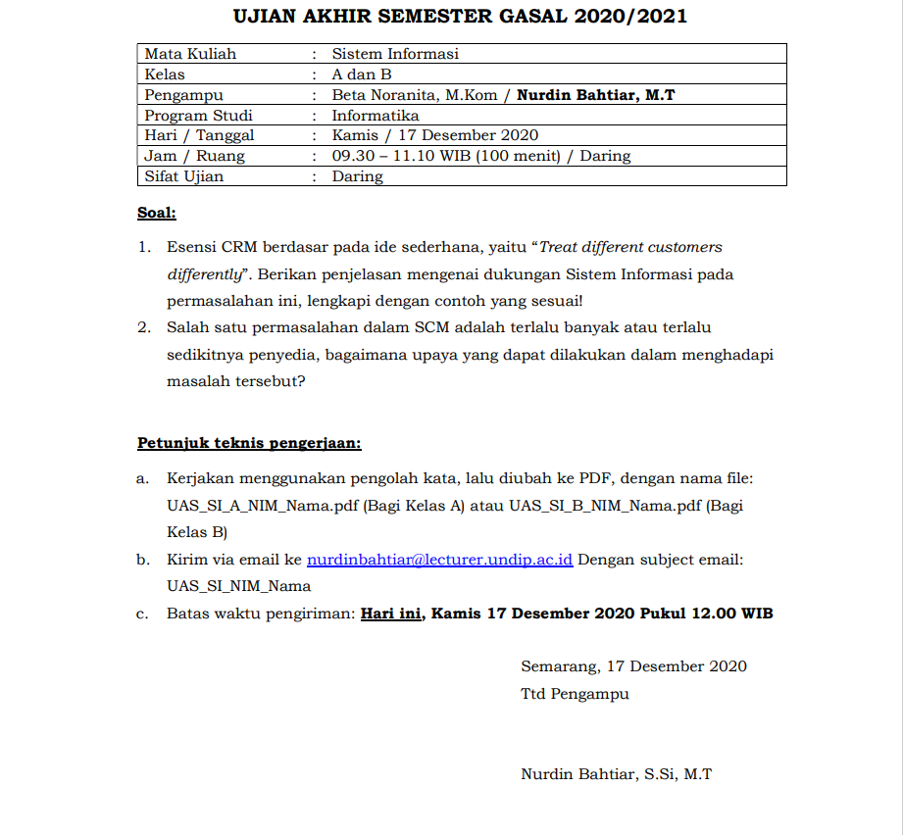

****DIKLAT HMIF Page 15